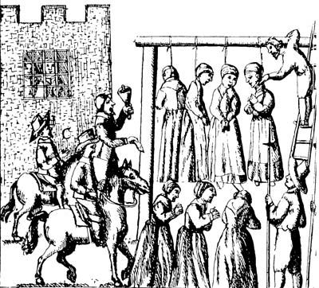

Convicted and Hanged: Bridget Bishop, George Burroughs, Martha Carrier, Martha Corey, Mary Easty, Sarah Good, Elizabeth Howe, George Jacobs, Sr., Susannah Martin, Rebecca Nurse, Alice Parker, Mary Parker, John Proctor, Ann Pudeator, Wilmott Redd, Margaret Scott, Samuel Wardwell, Sara Wildes, John Willard

Pressed to Death with Stones: Giles Corey

Accused Who Died in Prison Before Execution: Sarah Osborn, Roger Toothaker, Lyndia Dustin, Ann Foster (As many as thirteen others may have died in prison - sources conflict as to the exact number of prison deaths)
Source: Court records of the town of Salem, 1692.

