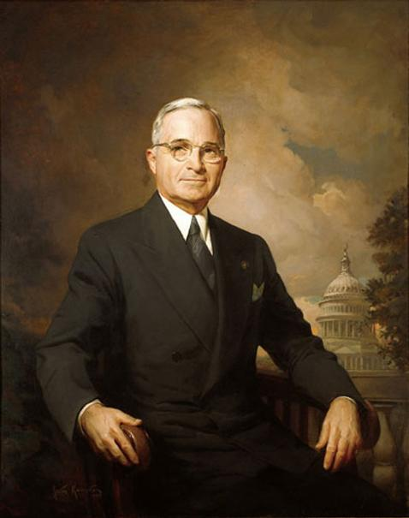 | 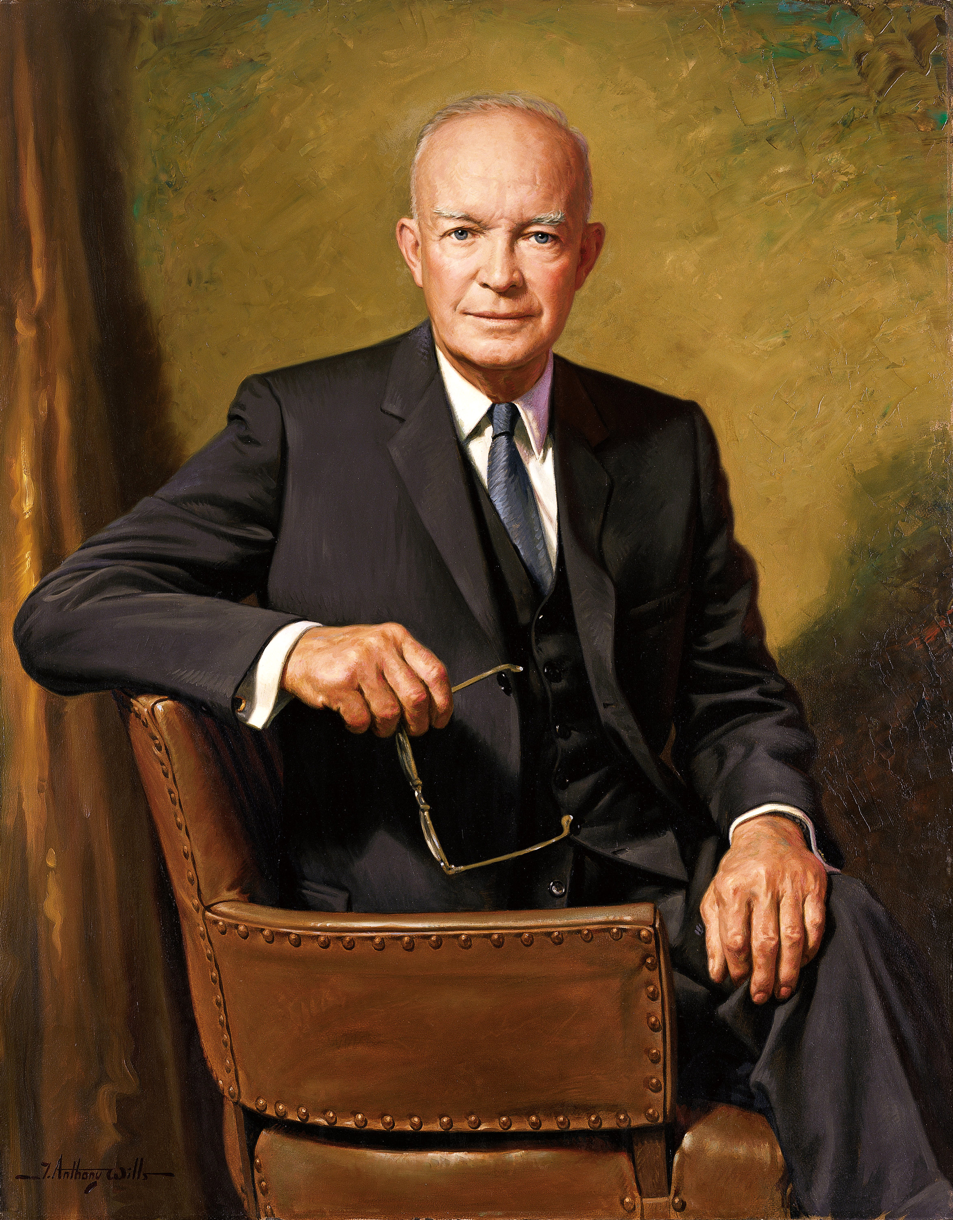 | 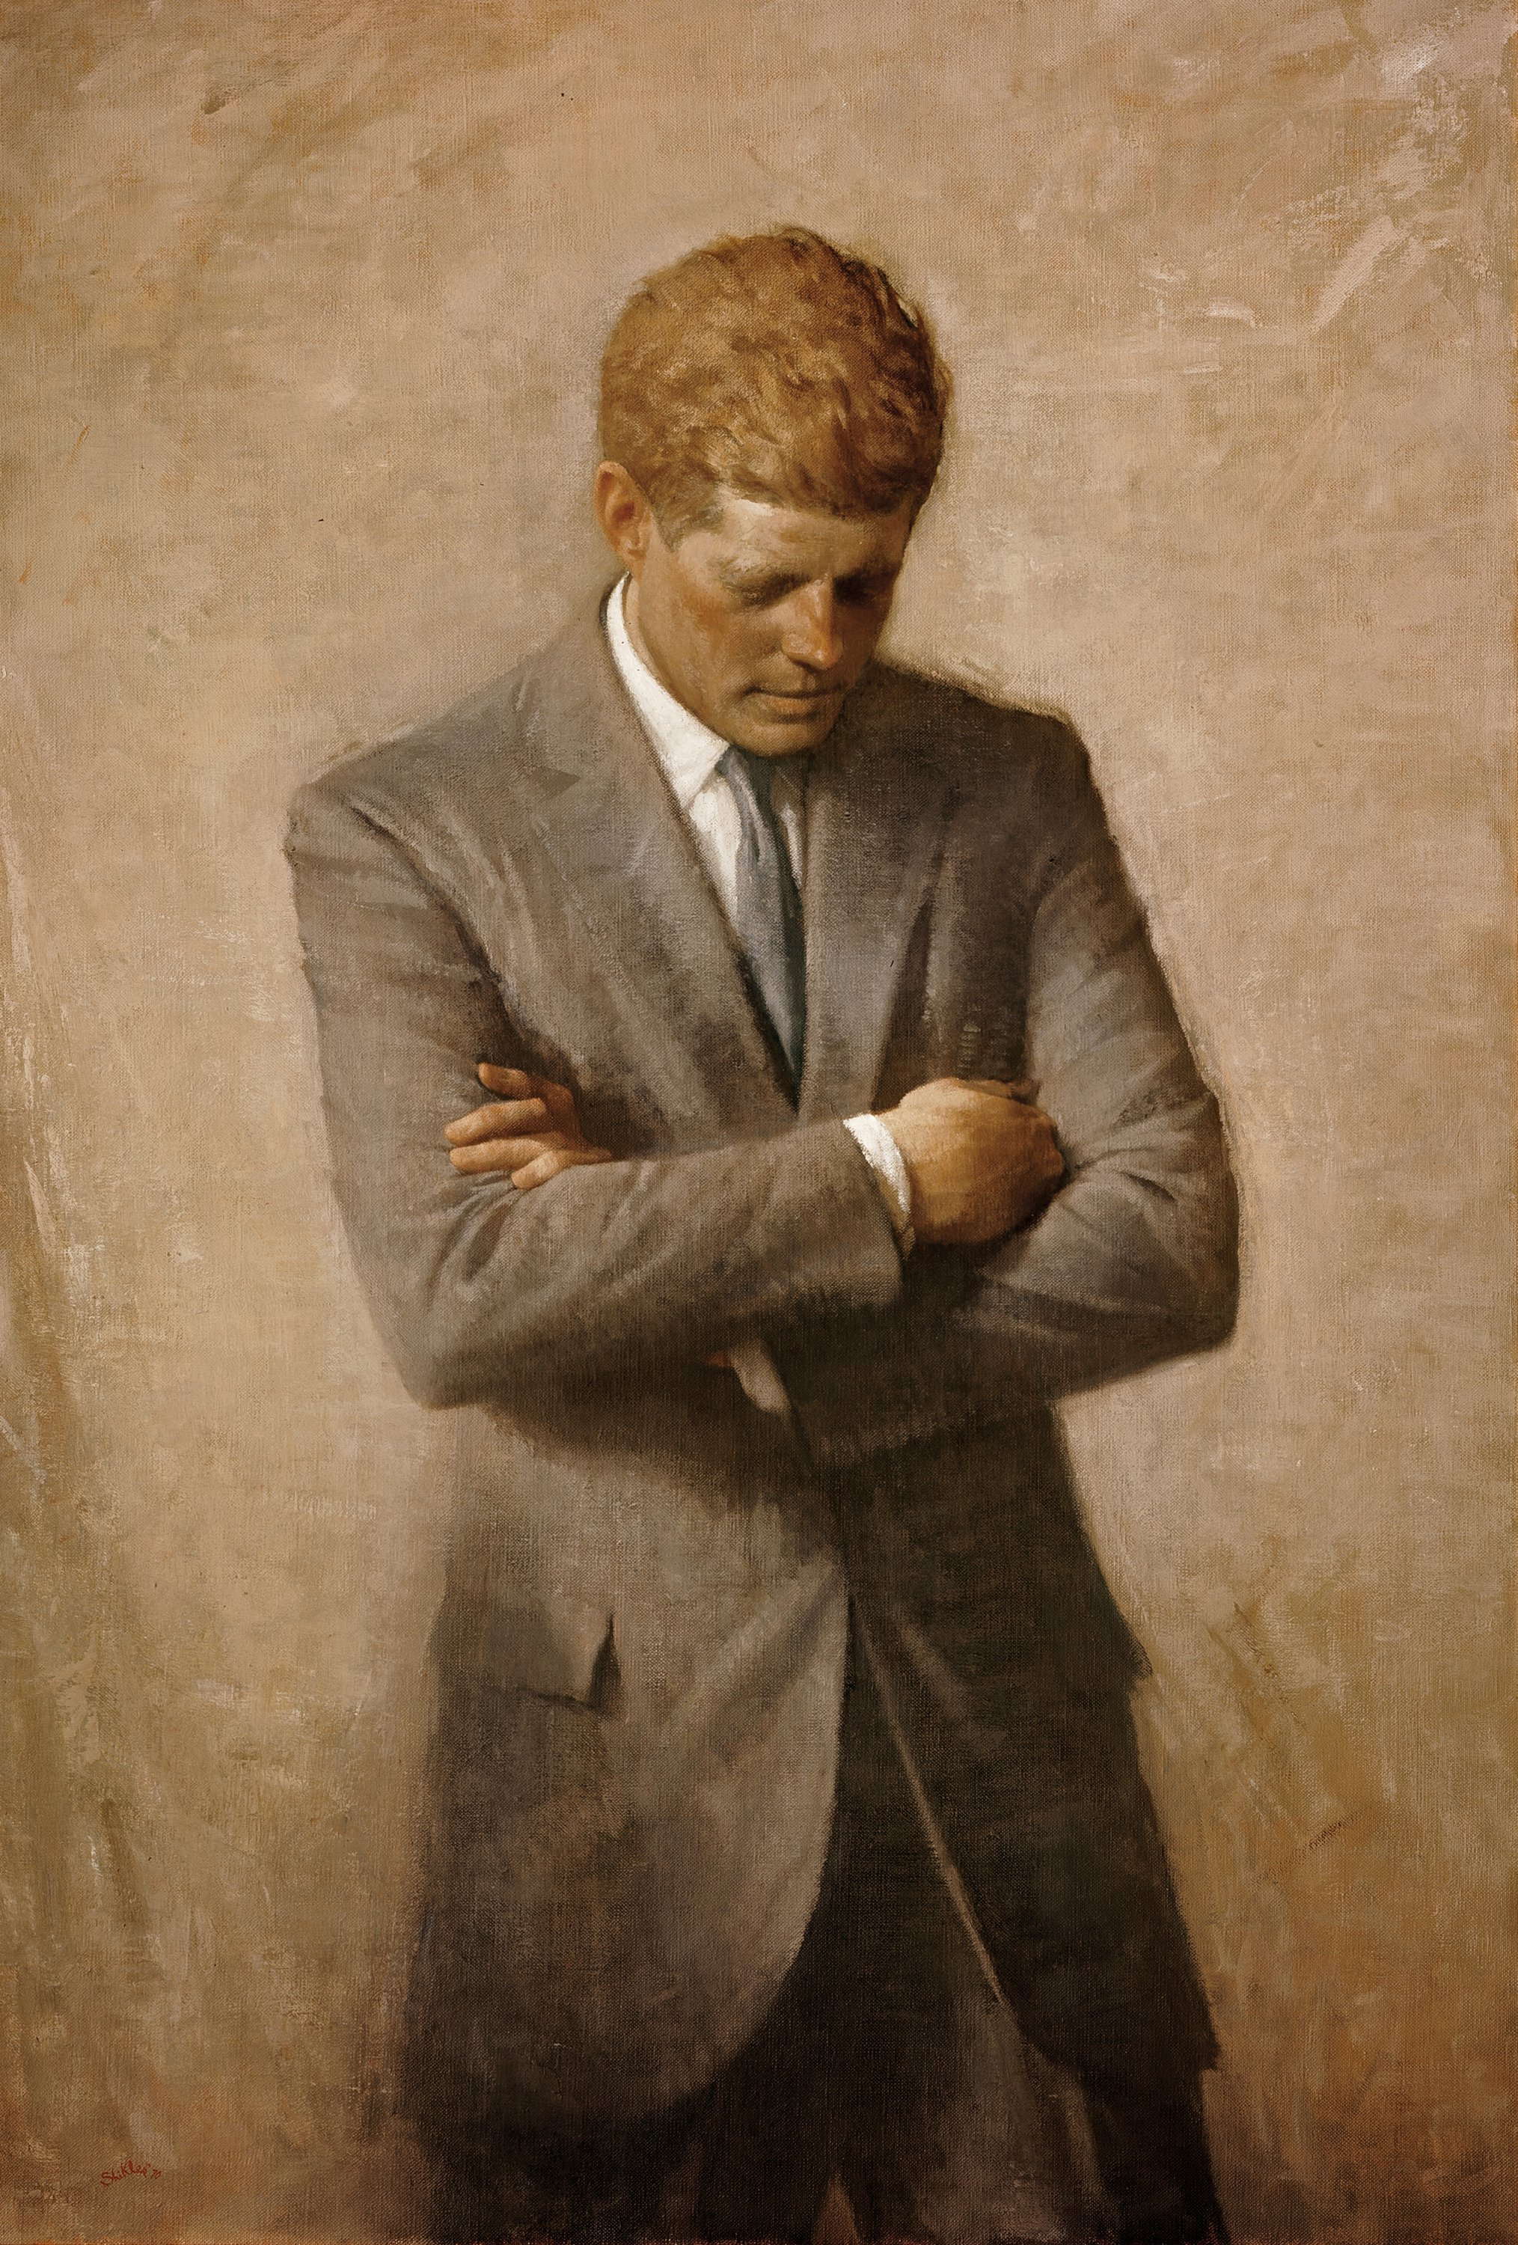 | 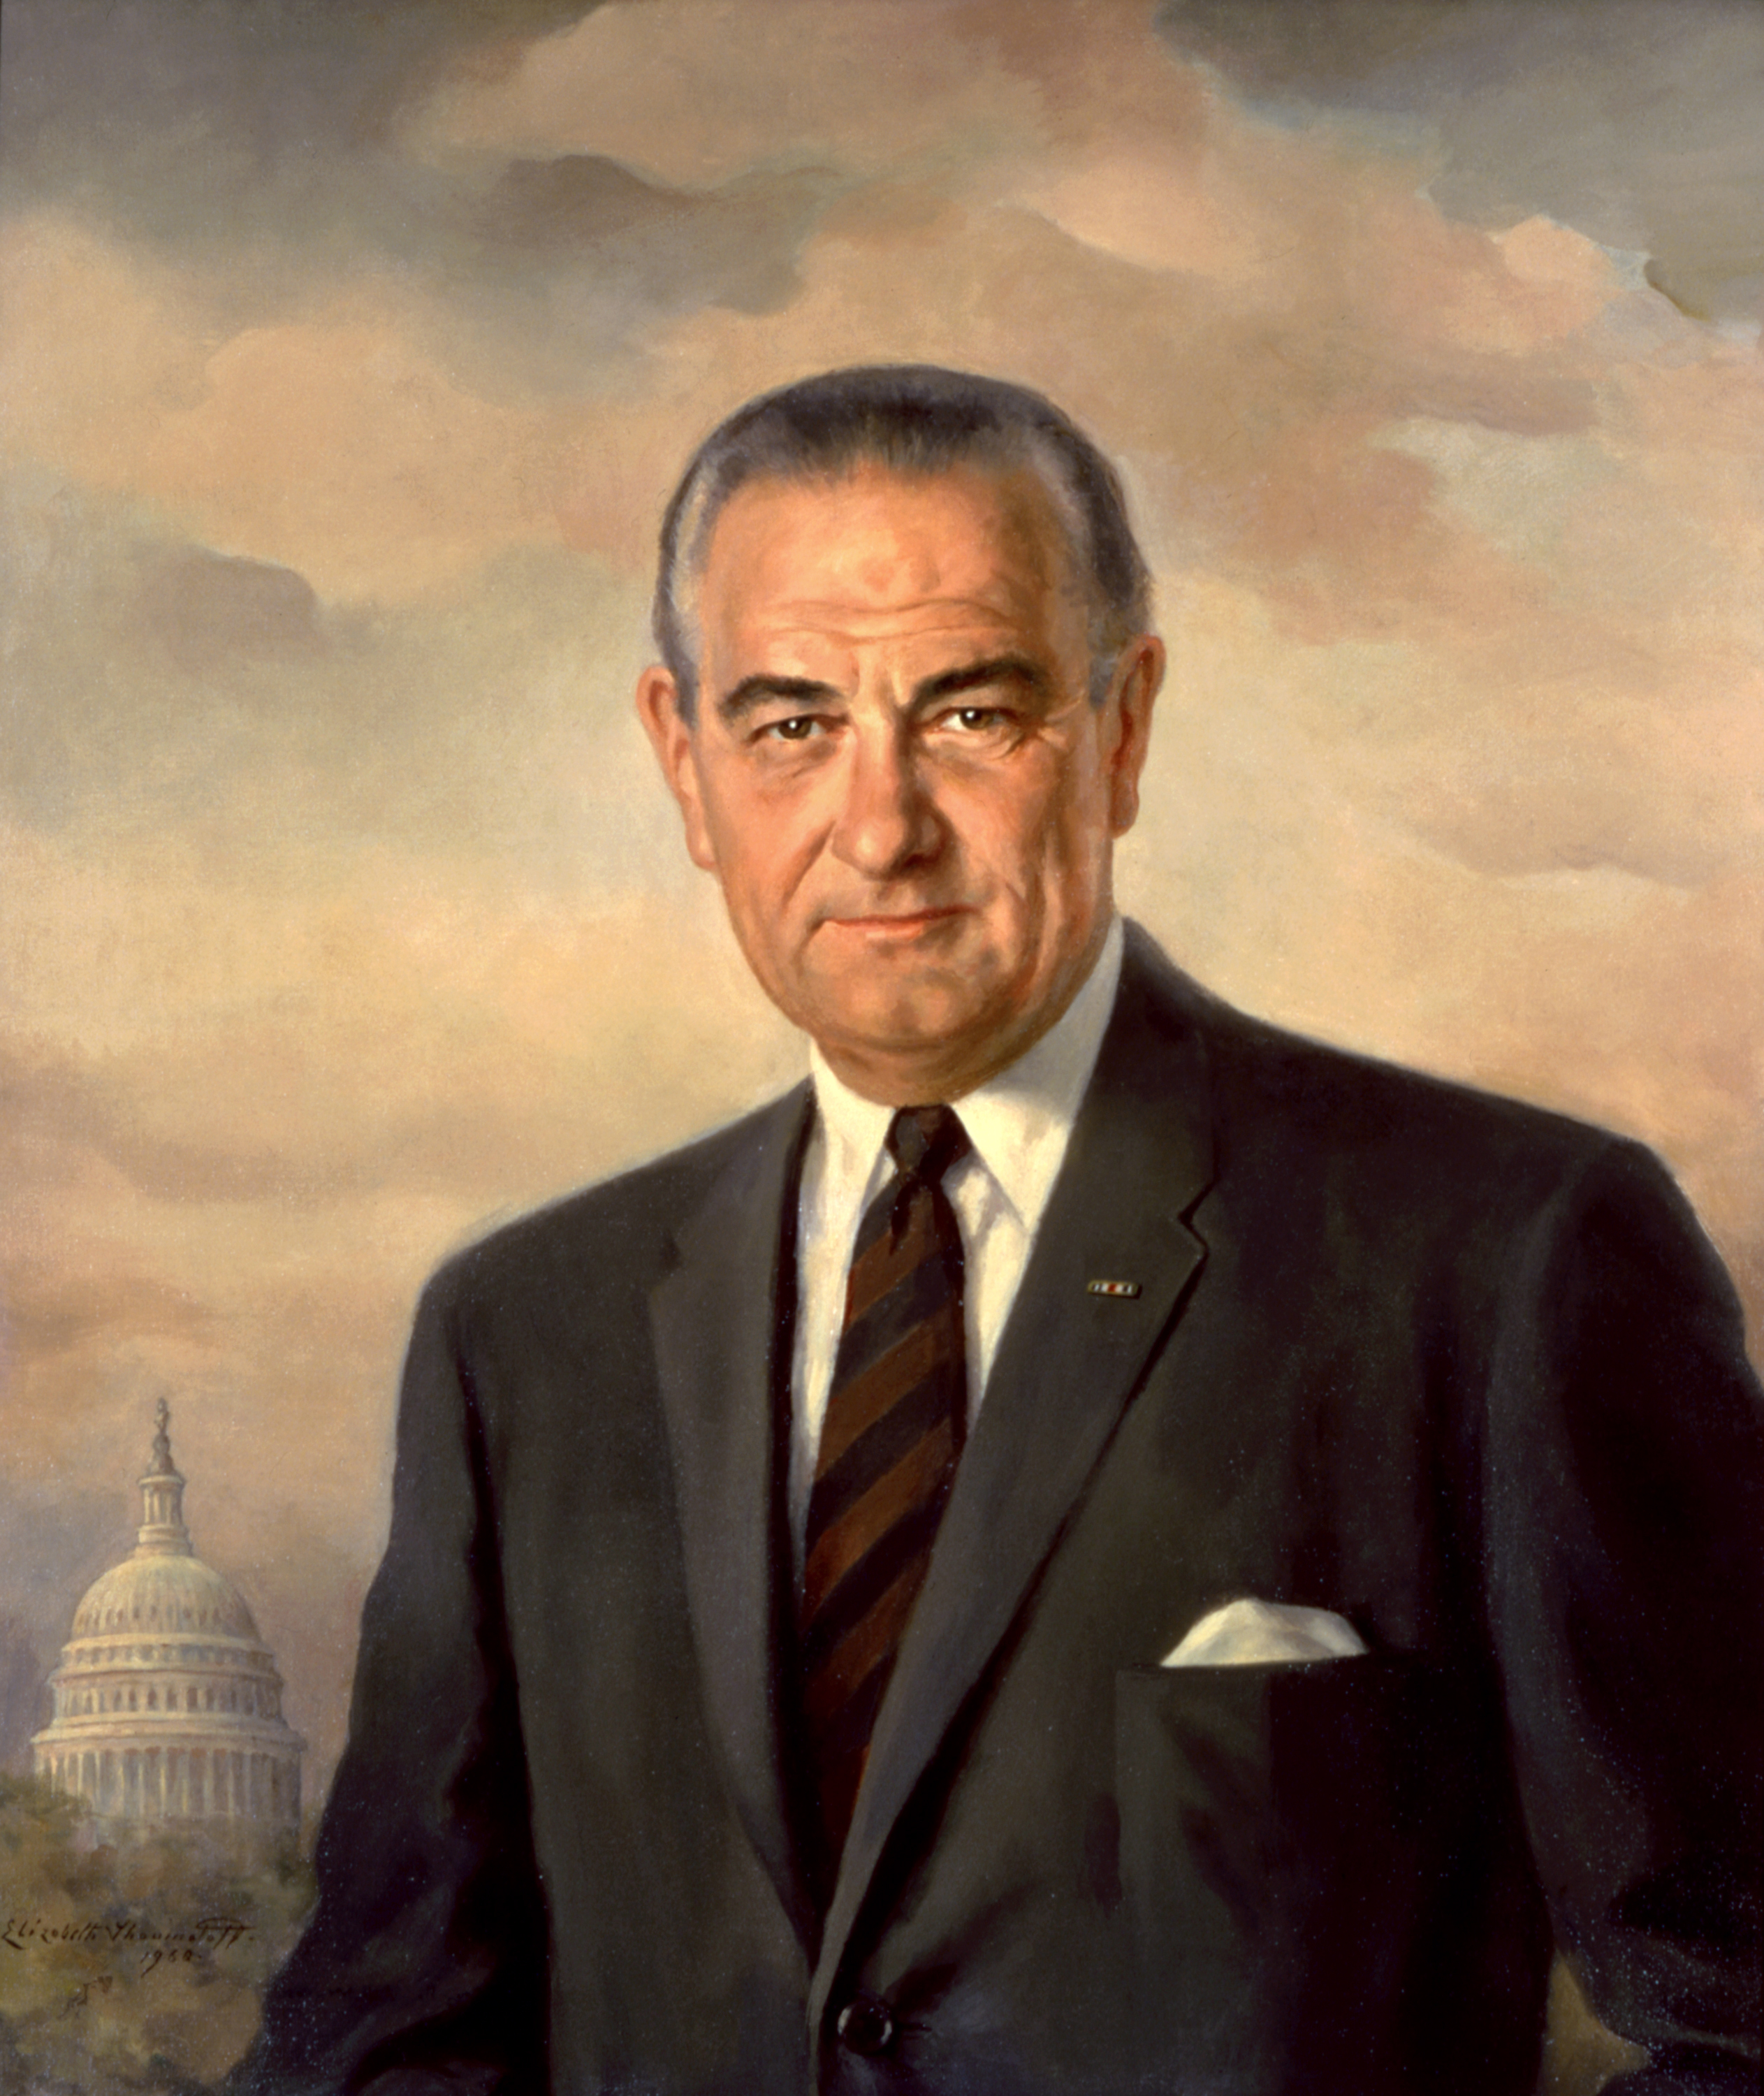 | 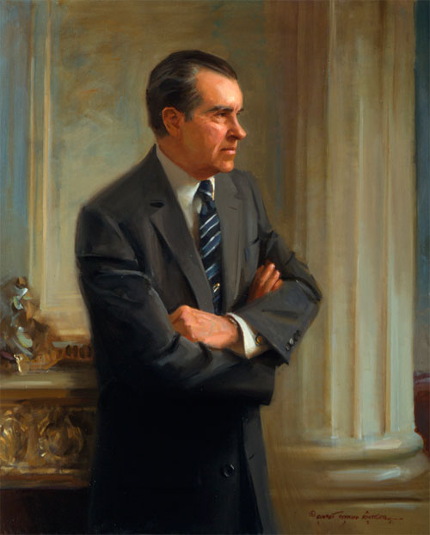 | 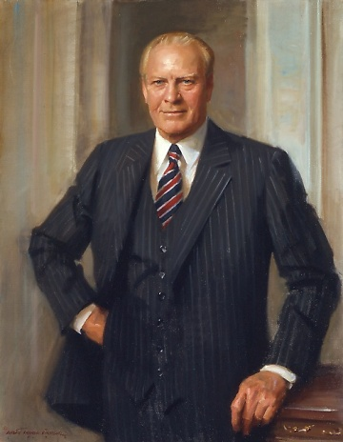 | 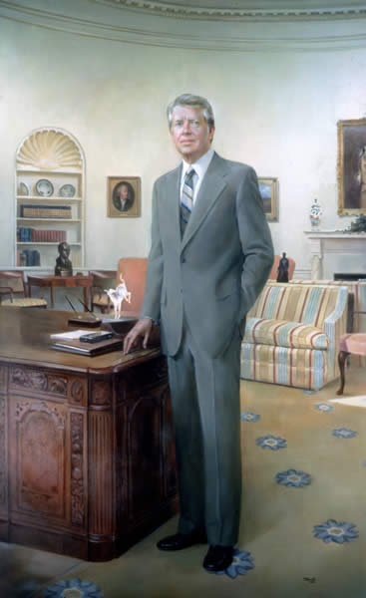 | 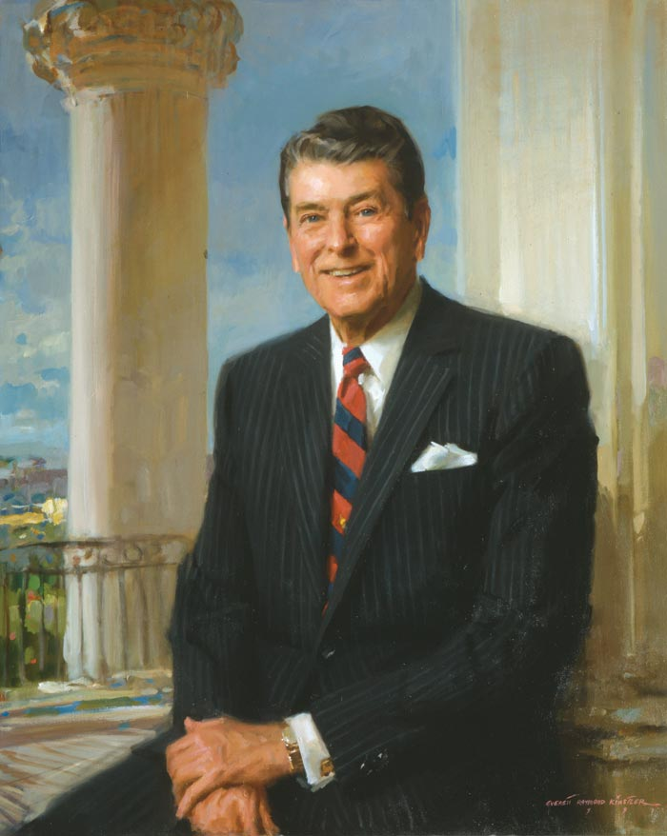

Period 8: 1945 to 1980

Cold War: 1950s through the 1980s

Organizing Principles - Between World War II and 1960, the New Deal philosophy that the government was a legitimate
agent of social welfare became firmly embedded in the American mind.

The Cold War led the United States to pursue an ambivalent policy of confrontation, negotiation,
and preventive maintenance between 1945 and 1970.

Disillusionment with the increasingly violent protest of the 1960s led to the entrenchment of
conservative ideology between 1968 and 1992.

The Cold War led the United States to pursue an ambivalent policy of confrontation, negotiation,
and preventive maintenance between 1945 and 1970.

Date | Quarter 2  Class Discussion Topic | Assignment
January 6 | - Return Papers!  - World War II Conferences  - Introduce the New World Order  - 1950’s Culture & Consumerism | - Amsco: Chapter 26  - Flipped Lesson: Harry Truman and Eisenhower Foreign Policy
January 7 | - Open Note Quiz on Flipped Lesson  - Finish 1950’s Culture & Consumerism  - Context and Thesis Assessment | - Amsco: Chapter 27  - After School Review 2:30-  3:30
January 8 | Happy Birthday Elvis!!  - Introduce Kennedy and the Election of 1960- Who are the candidates  - Kennedy Domestic Policy | - Catch Up on Amsco
January 9 | - Kennedy Foreign Policy  - Introduce Interests in Vietnam  - Kennedy’s Assassination | - Amsco: Chapter 28  - After School Review 2:30-3:30
January 10 | - Open Note Quiz on Flipped Lesson  - Pick up on LBJ Domestic- The Great Society  - LBJ Foreign Policy- Vietnam  - Context and Thesis Assessment | - Watch Jocz Videos as necessary for support on Vietnam

Date | Quarter 2  Class Discussion Topic | Assignment
January 13 | - Finish Vietnam  - Rise of the Civil Rights Movement (1950s-1960s) | - Amsco: Chapter 29  - Study
January 14 | - Civil Rights through the 1960s  - Election of 1968 & Rise of Nixon  - Nixon Foreign and Domestic Policy | - After School Review: 2:30-  3:30  - Study
January 15 | - Finish Nixon Foreign & Domestic Policies  - Watergate  - Gerald Ford and the 1970s | - Study
January 16 | - Finish Gerald Ford  - Jimmy Carter!  - Election of 1980 | - Study  - After School Review: 2:30-  3:30
January 17 | Finish Nixon’s Presidency  Ford and Carter in a Day | - Study  - Reading Logs Due Today

Date | Quarter 2  Class Discussion Topic | Assignment
January 20 | Martin Luther King Day- No School
January 21 | 1st & 2nd Block Exams
January 22 | 3rd & 4th Block Exams
January 23 | English II and Math I EOC
January 24 | Biology and Math III EOC

Date | Quarter 3  Class Discussion Topic | Assignment
January 27 | Make Up Exams
January 28 | First Day of 2nd Semester
January 29 | Teacher Work Day- No School!
January 30 | Regular School Day
January 31 | Regular School Day

