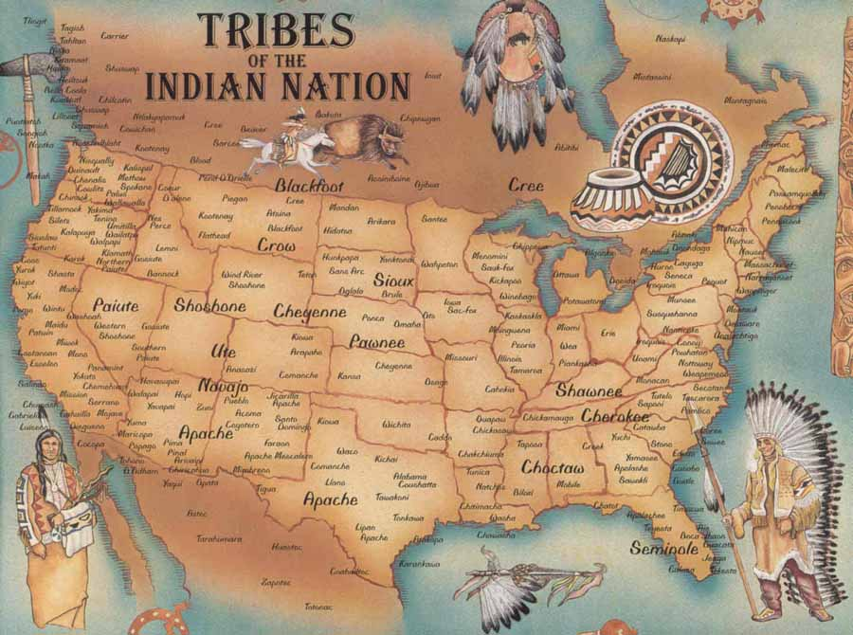

Organizing Principals
Before the year 1607, North American settlement was defined by the both nomadic and sedentary traditions of the people native to the North American continent. Their reliance on the land and their religious faiths based in nature, although highly developed, would ultimately mark them at savages by the “enlightened” European explorers.

Between 1607 and 1763, the British North American colonies developed experience in, and the expectation of self-government in the political, religious, economic, and social aspects life.

Topics: native people, exploration, colonization, governmental development, economic development, religious development,

Colonial wars, salutary neglect, social development, push and pull factors, French and Indian War, free labor, slavery.

Date | Week 1 Class Topic | Nightly Assignments | Done
January  27 | Exam Make Up Day
January  28 | Introductions/Course Outline  Unit Primary Source Pack  Overview of Period 1:  - Native Inhabitants and the Columbian Exchange | AP Star  Read Syllabus  Bartram Primary Source
January 29 | Teacher Work Day! | Mini Documents 1.4-1.9  Clovis Point Article
January  30 | Opening: Discussion of Bartram  - Finish Native Inhabitants and the Columbian Exchange  - Non-English Settlement in the New World  - Jamestown  Check Out Amsco Books | Begin Chart on Characteristics of Settlement  Amsco: Chapter 2  -------- Open House!!! ----------
January  31 | Jamestown and Chesapeake Settlement  Other Southern Colonies and Purposes | Mayflower Compact and Jamestown Brides  Modell of Christian Charity

Date | Week 2 Class Topic | Nightly Assignments | Done
February 3 | Opening: Our Plantation is Very Weak  The Influence of Puritanism and New England Settlement | Flipped Class Lecture: The Role of War and Strife in the Colonies  Modell of Christian Charity
February 4 | Opening: Quakers Primary Source (William Penn)  Middle Colonies and the Influence of the Dutch and Quakers  Questions/Discussion on Flipped Lesson  Finish the Middle Colonies  Slavery in the Colonies | Amsco: Chapter 3  VA Laws for Blacks
February 5 | Opening: Context and Thesis Writing  Finish Slavery in the Colonies  The First Great Awakening and Salem Witch Trials | Context and Thesis: Amsco Page 63  Questions 3 OR 4
February 6 | The First Great Awakening and Salem Witch Trials  Review Thesis and Context Writing | Multiple Choice Questions: p.40-42  ~With rational
February 7 | Introduce the DBQ  ~Begin to write DBQ | DBQ and Study for Quest

Date | Week 3 Class Topic | Nightly Assignments | Done
February 10 | Period 1 & 2 Quest  Start Period 3 | (New Unit- 1st Assignment) Amsco: Chapter 4

Items Due For this Unit: on February 5
- Reading Logs
- Vocabulary
- Primary Source Pack
- Multiple choice questions

