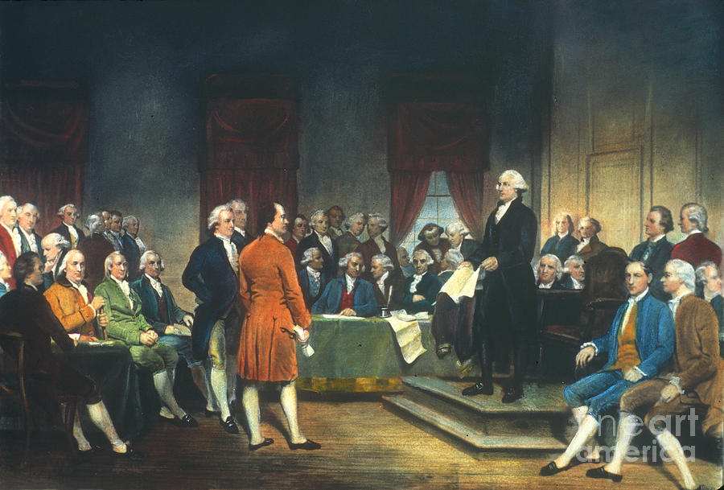
Unit Thesis Statements:
- Between 1763 and 1776, British attempts to exert control over the colonies led to violent, organized, and successful resistance.
- The Articles of Confederation provided a reasonable and workable transition from the unitary System of British rule to the federal system established under the Constitution.
- Under the new Constitution, George Washington assumes the presidency and begins to set the precedence of the presidency and the role of the American government.
Topics:
- British tax policy, colonial reaction, inter-colonial unity, inter-colonial conflict, independence movement, Revolution, revolutionary change, Articles of Confederation, Constitution, Bill of Rights, founding fathers, precedence, French Revolution, American foreign policy, constitutional challenges
Date | Week 3 Class Topic | Nightly Assignments
February 10 | Period 1 & 2 Quest  Introduce DBQ | Amsco: Chapter 4
February 11 | French and Indian War  - Causes and Outcomes  - Treaty of Paris of 1763  Introduce: British Assertion of Control and the End of Salutary Neglect | Common Sense
February 12 | British attempts to reassert control & colonial reactions  The End of Salutary Neglect  American Revolution | Amsco: Chapter 5  Declaration of Independence  Finish Revolution on Flipped Video as Necessary
February 13 | Opening-The Greatest Breakup Letter in History  Finish American Revolution  Articles of Confederation  Introduce SAQ | Prince Hall  SAQ # 3 on Amsco p.83
February 14 | Constitutional Convention  Washington’s Cabinet | Constitution of Vermont  Letter to John Jay

Date | Week 4 Class Topic | Nightly Assignments
February 17 | Holiday- President’s Day- No School  - Flipped Video- Finish Anything from last week  - Flipped Video- Washington Domestic Policy and Formation of Political Parties | Amsco: Chapter 6  Janus
February 18 | Teacher Work Day- No School  - Washington’s Foreign Policy | Bill of Rights Excerpts  Multiple Choice p.79-81
February 19 | Flipped Video Open Note Quiz  “Welcome folks, to the Adams Administration”  - Adam’s Domestic Policy | Hamilton to George Washington  Multiple choice p.97-99  SAQ p.101
February 20 | Finish Period 3/Wrap Up Ideas  SAQ Practice  Thesis and Contextualization Practice | Study
February 21 | Period 2 & 3 Exam | Rest and Recover

