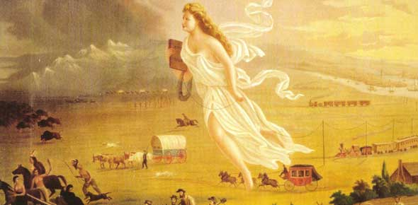
PERIOD 4: THE AGE OF JEFFERSON THROUGH MANIFEST DESTINY
UNIT THESISES-
- The United States underwent a revolution when Thomas Jefferson became president, establishing a peaceful transition of power within the American government. The Era of Good Feelings will hide the underlying issues that begin to emerge in American politics.
- During the “Reign of Jackson”, politics became more democratic and the power of the president increased. America became more optimistic and expansionistic while sectionalism supplanted nationalism.
TOPICS-
- Jeffersonian democracy, Supreme court cases, territorial expansion, national market economy, industrial revolution, transportation revolution, agricultural revolution, nationalism, sectionalism, Manifest Destiny, Jacksonian Democracy, Era of Good Feelings, War of 1812
 | Week 6 Class Topic | Nightly Assignments
March  2 | Finish Jefferson  Election of 1808 and James Madison  War of 1812 | The Marshall Court Legacy Graphics (Due at end of unit)  3rd Block- Lecture on Madison and War of 1812  2nd Block- M/C p 144-146 & SAQ #1
March  3 | Finish the War of 1812  The Era of Good Feelings  The Domestic and Foreign Policy of James Monroe | Flipped Class/Video: The Market Revolution  Amsco Chapter 8
March 4 | Opening: Tea Table Talk  The Second Great Awakening | Excerpts: Women and Antebellum Reform
March 5 | Opening: Ain’t I A Woman?  Finish the Second Great Awakening  The Elections of 1824 & 1828  Jackson: The Man, The Myth, The Legend | Amsco Chapter 9  Flipped Lesson/Video:  The Elections of 1824 & 1828
March 6 | Jackson- A man who cannot be contained to one day of lecture  West Point Visit! | Amsco Chapter 10

 | Week 8 Class Topic | Nightly Assignments
March  9 | No School  Flipped Lesson- Jackson
March  10 | The Van Buren Administration  The Harrison and Tyler Administration  Manifest Destiny | Amsco Chapter 11
March  11 | The Polk Administration  The Texas War for Independence | Amsco Chapter 12
March 12 | Period 4 Quest  Start Period 5 | Study
March 13 | Beginning of Period 5  The Mexican-American War and the Changing of the Slavery Conversation

